Electronic Instrumentation and Optoelectronics LAB

LAB3: Measuring with instruments. Systematic and random effects.
The aim of this LAB session is to compare the characteristics of the multimeter and oscilloscope when measuring the RMS value frequency of different signals.
In order to facilitate the configuration and acquisition of measurements from the instruments, we will develop a LabView program using specific instrument drivers (see annex information).

PRE-LAB Exercises.
Consider:
a) The estimation of the uncertainty from the instrument specifications is type B (non-statistical method). If the distribution type is unknown, it is assumed that the distribution (probability density function) is uniform. The distribution type of the multimeter (HP34401) specifications is known, we can deduce the distribution and the coverage factor k used in specifications from the manual (see p. 227).
b) Assume that the equipment is calibrated once a year and the laboratory temperature is between 18 ° C and 28 ° C. Disregarding the specification aging (aging).
c) If for a given measure is not specified the accuracy it means that the manufacturer does not warrant that this measure can be done correctly with this instrument (the measurement uncertainty is unknown).
d) In the function generator the accuracy is specified at 1 kHz, we must add the flatness specification for different frequencies than 1 kHz.
e) In some waveforms with high amplitude and low RMS value additional errors that are dependent on the peak factor must be considered. The crest factor is defined as the peak value divided by the RMS value.
f) Perform all theoretical calculations and measurements with the multimeter on the scale that provides less uncertainty.

To Do:
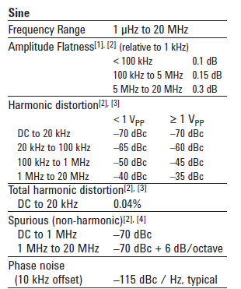
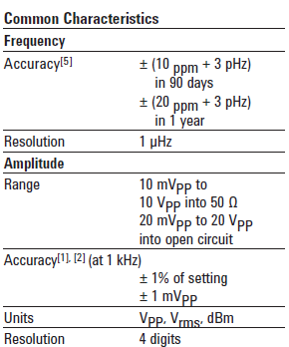
- From the specifications of the function generator calculate the standard uncertainty in the frequency and amplitude of a sinusoidal signal of 1 Vrms of amplitude a nd 1 Hz, 1 kHz and 1 MHz.

This is the information that we get from the data sheet.
Whe know that $V_{rms}=\frac{V_{pp}}{2CF};CF=\sqrt{2}$
The amplitude flatness for a f < 100 KHz = 0.1dB, to dBV
$$0.1 dBV=20\log\left(V\right)→V=1.011579V$$
The amplitude flatness for a 100 KHz < f < 5 MHz = 0.15dB, to dBV
$$0.15 dBV=20\log\left(V\right)→V=1.017419V$$
The frequency accuracy is detailed in the presented chart (orange)

To calculate the amplitude uncertainty:

- for a f < 100 kHz
$$Accuracy= ±\left(1\%·1V±\frac{1m V_{pp}}{2\sqrt{2}}\right)·1.011579=10.473mV$$
$$Uncertanty =\frac{μ}{k}=\frac{10.473}{\sqrt{3}}=6.04mV$$

- for a 100 kHz < f < 5 MHz
$$Accuracy= ±\left(1\%·1V±\frac{1m V_{pp}}{2\sqrt{2}}\right)·1.017419=10.53mV$$
$$Uncertanty =\frac{μ}{k}=\frac{10.473}{\sqrt{3}}=6.08mV$$

To calculate the frequency uncertainty:
- For 1 Hz and 1 kHz and 1MHz
$$Accuracy = ± (20 μHz· 1Hz + 3pHz)= 20μHz$$
$$Uncertainty: U =\frac{μ}{k}→\frac{20μHz}{\sqrt{3}}= 11, 55μHz$$
- For 1 kHz
$$Accuracy = ± \left(20 μHz· 1kHz + 3pHz\right)= 20mHz$$
$$Uncertainty: U =\frac{μ}{k}→\frac{20μHz}{\sqrt{3}}= 11, 55mHz$$
- For 1 MHz
$$Accuracy = ± \left(20 μHz· 1MHz + 3pHz\right)= 20Hz$$
$$Uncertainty: U =\frac{μ}{k}→\frac{20μHz}{\sqrt{3}}= 11, 55Hz$$

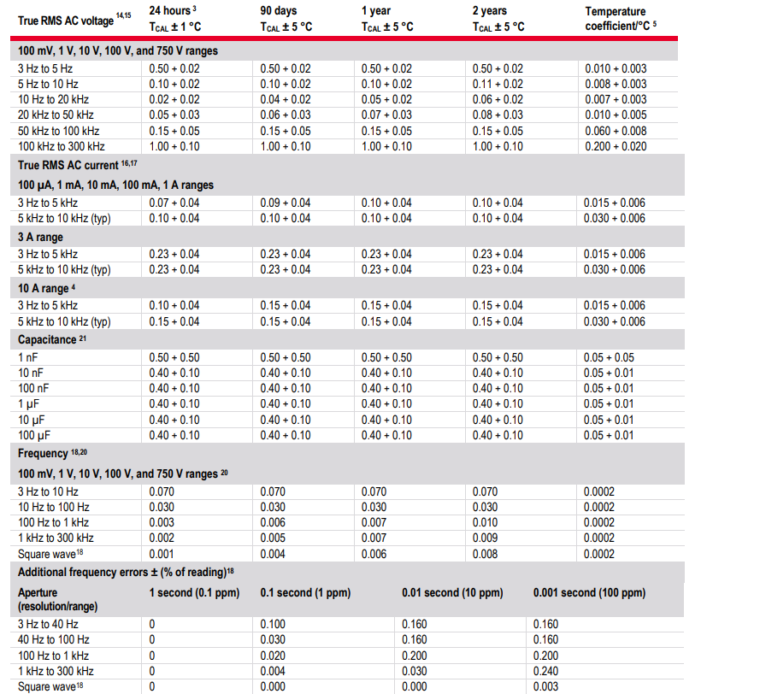
- From the specifications of the multímeter , calculate the standard uncertainty in frequency and amplitude of a sinusoidal signal of 1 Vrms of amplitude and 1 Hz, 1 kHz and 1 MHz (with a 5 ½-digit resolution with medium filter in AC coupling).
K=2
Amplitude uncertainty for 1kHz

$$Accuracy= ±\left(0.05\%·1V+0.02\%·1V\right)=700μV$$
$$Uncertanty =\frac{μ}{k}=\frac{700μV}{2}=350μV$$
We didn’t calculated for 1Hz and 1MHz because de range is from 3Hz to 300kHz.

Frequency uncertainty for 1kHz

$$Accuracy= ±(9.7\%·1kHz)=7Hz$$
$$Uncertanty =\frac{μ}{k}=\frac{7Hz}{2}=3.5Hz$$

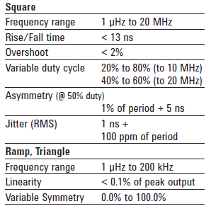
- Repeat the calculations for a square and triangular waves.

Square:
- For 1 Hz and 1 kHz and 1MHz
$$Accuracy = ± (20 μHz· 1Hz + 3pHz)= 20μHz$$
$$Uncertainty: U =\frac{μ}{k}→\frac{20μHz}{\sqrt{3}}= 11, 55μHz$$
- For 1 kHz
$$Accuracy = ± \left(20 μHz· 1kHz + 3pHz\right)= 20mHz$$
$$Uncertainty: U =\frac{μ}{k}→\frac{20μHz}{\sqrt{3}}= 11, 55mHz$$
- For 1 MHz
$$Accuracy = ± \left(20 μHz· 1MHz + 3pHz\right)= 20Hz$$
$$Uncertainty: U =\frac{μ}{k}→\frac{20μHz}{\sqrt{3}}= 11, 55Hz$$
Amplitude for 1kHz (not possible the other two)
$$Accuracy= ±\left(0.05\%·1V+0.02\%·1V\right)=700μV$$
$$Uncertanty =\frac{μ}{k}=\frac{700μV}{2}=350μV$$
Frequency for 1kHz
$$Accuracy= ±(6\%·1kHz)=6Hz$$
$$Uncertanty =\frac{μ}{k}=\frac{6Hz}{2}=3Hz$$

Triangular:

- For 1 Hz and 1 kHz and 1MHz
$$Accuracy = ± (20 μHz· 1Hz + 3pHz)= 20μHz$$
$$Uncertainty: U =\frac{μ}{k}→\frac{20μHz}{\sqrt{3}}= 11, 55μHz$$
- For 1 kHz
$$Accuracy = ± \left(20 μHz· 1kHz + 3pHz\right)= 20mHz$$
$$Uncertainty: U =\frac{μ}{k}→\frac{20μHz}{\sqrt{3}}= 11, 55mHz$$
- For 1 MHz – NOT possible, the range does not get to 1MHz

Amplitude for 1kHz (not possible the other two)
$$Accuracy= ±\left(0.05\%·1V+0.02\%·1V\right)=700μV$$
$$Uncertanty =\frac{μ}{k}=\frac{700μV}{2}=350μV$$

It specifies that it is only possible to calculate the frequency for square waves, not triangular.

LAB exercises
LAB3-1.- Make a Labview VI, able to configure the amplitude, frequency and the kind of signal of the function generator. (Use the incomplete example VI provided on ATENEA).

LAB3-2.- Make a Labview VI, able to measure the RMS value of a signal with the DMM. (Use the incomplete example VI provided on ATENEA).

LAB3-3.- Measure with the multimeter the RMS value for each of the three signals (sinus, square and triangle) at the 3 different frequencies considered in the PRELAB exercices.

LAB3-4.- Discuss the measures. Are in agreement with the specifications?

LAB3-5 Make a Labview VI, able to measure the RMS value of a signal with the osciloscope. (Use the incomplete example VI provided on ATENEA).

LAB3-6.- Repeat measures of LAB3-3 with the oscilloscope and compare with the previous ones. Are similar? What are the differences?

LAB3-7.- Configure the function generator for a frequency of 1 kHz. Take 100 measurements for each waveform with the multimeter and the oscilloscope. What is the Type A uncertainty of the measurements? Is it comparable with the Type B uncertainty? Why?

